**Mobile phone price fixed on the various factors like processor, RAM, Internal memory etc., There are 21 features given in the dataset. Classify the mobile price range as 0,1,2 or 3 based upon the features given in the dataset.**

**Class 0 – low cost**

**Class 1 – medium cost**

**Class 2 - high cost**

**Class 3 – very high cost**

**Use SVM algorithm for classification.**

In [63]:

**import** numpy **as** np **import** pandas **as** pd **import** matplotlib.pyplot **as** plt **import** seaborn **as** sns **%matplotlib** inline **import** warnings warnings**.**filterwarnings("ignore")

In [21]:

pd**.**set_option('display.max_columns', **None**)

In [22]:

df **=** pd**.**read_csv('mobile data set - mobile data set.csv')

In [23]:

df**.**head(10)

Out[23]:

**battery_power blue clock_speed dual_sim fc four_g int_memory m_dep mobile_wt n_cores pc px_height px_width ram sc_h sc_w talk_time**

1. 842 0 2.2 0 1 0 7 0.6 188 2 2 20 756 2549 9 7 19
2. 1021 1 0.5 1 0 1 53 0.7 136 3 6 905 1988 2631 17 3 7
3. 563 1 0.5 1 2 1 41 0.9 145 5 6 1263 1716 2603 11 2 9
4. 615 1 2.5 0 0 0 10 0.8 131 6 9 1216 1786 2769 16 8 11
5. 1821 1 1.2 0 13 1 44 0.6 141 2 14 1208 1212 1411 8 2 15
6. 1859 0 0.5 1 3 0 22 0.7 164 1 7 1004 1654 1067 17 1 10
7. 1821 0 1.7 0 4 1 10 0.8 139 8 10 381 1018 3220 13 8 18
8. 1954 0 0.5 1 0 0 24 0.8 187 4 0 512 1149 700 16 3 5
9. 1445 1 0.5 0 0 0 53 0.7 174 7 14 386 836 1099 17 1 20
10. 509 1 0.6 1 2 1 9 0.1 93 5 15 1137 1224 513 19 10 12



**EDA**

In [4]:

df**.**shape

Out[4]:

(2000, 21)

In [31]:

df**.**columns

Out[31]:

Index(['battery_power', 'blue', 'clock_speed', 'dual_sim', 'fc', 'four_g',

'int_memory', 'm_dep', 'mobile_wt', 'n_cores', 'pc', 'px_height',

'px_width', 'ram', 'sc_h', 'sc_w', 'talk_time', 'three_g',

'touch_screen', 'wifi', 'price_range'], dtype='object')

In [ ]:

'battery_power', 'blue', 'clock_speed', 'dual_sim', 'fc', 'four_g', 'int_memory', 'm_dep', 'mobile_wt', 'n_cores', 'pc', 'px_height', 'px_width', 'ram', 'sc_h', 'sc_w', 'ta

In [5]:

df**.**info()

<class 'pandas.core.frame.DataFrame'>

RangeIndex: 2000 entries, 0 to 1999

Data columns (total 21 columns):

# Column Non-Null Count Dtype

--- ------ -------------- -----

1. battery_power 2000 non-null int64
2. blue 2000 non-null int64
3. clock_speed 2000 non-null float64
4. dual_sim 2000 non-null int64
5. fc 2000 non-null int64
6. four_g 2000 non-null int64
7. int_memory 2000 non-null int64
8. m_dep 2000 non-null float64
9. mobile_wt 2000 non-null int64
10. n_cores 2000 non-null int64
11. pc 2000 non-null int64
12. px_height 2000 non-null int64
13. px_width 2000 non-null int64
14. ram 2000 non-null int64
15. sc_h 2000 non-null int64
16. sc_w 2000 non-null int64
17. talk_time 2000 non-null int64
18. three_g 2000 non-null int64
19. touch_screen 2000 non-null int64
20. wifi 2000 non-null int64 20 price_range 2000 non-null int64 dtypes: float64(2), int64(19) memory usage: 328.2 KB pc - Primary Camera mega pixels

fc - Front Camera mega pixels

sc_h - Screen Height of mobile in cm

sc_w - Screen Width of mobile in cm

m_dep - Mobile Depth in cm

px_width - Pixel Resolution Width

px_height - Pixel Resolution Height

ram - Random Access Memory in Mega Bytes

int_memory - Internal Memory in Giga Bytes

four_g - Has 4G or not

three_g - Has 3G or not

dual_sim - Has dual sim support or not

battery_power - Total energy a battery can store in one time measured in mAh

touch_screen - Has touch screen or not

clock_speed - speed at which microprocessor executes instructions

n_cores - Number of cores of processor

wifi - Has wifi or not

blue - Has bluetooth or not

mobile_wt - Weight of mobile phone

talk_time - longest time that a single battery charge will last when you are

price_range - This is the target variable with value of 0(low cost), 1(medium cost), 2(high cost) and 3(very high cost).

In [6]:

df**.**isnull()**.**sum()

Out[6]:

battery_power 0

blue 0

clock_speed 0 dual_sim 0

fc 0 four_g 0 int_memory 0 m_dep 0 mobile_wt 0 n_cores 0 pc 0 px_height 0 px_width 0 ram 0 sc_h 0 sc_w 0 talk_time 0 three_g 0 touch_screen 0

wifi 0

price_range 0 dtype: int64

In [7]:

df**.**duplicated()**.**sum()

Out[7]:

0

In [8]:

df**.**describe()

Out[8]:

**battery_power blue clock_speed dual_sim fc four_g int_memory m_dep mobile_wt n_cores ... px_height**

**count** 2000.000000 2000.0000 2000.000000 2000.000000 2000.000000 2000.000000 2000.000000 2000.000000 2000.000000 2000.000000 ... 2000.000000

**mean** 1238.518500 0.4950 1.522250 0.509500 4.309500 0.521500 32.046500 0.501750 140.249000 4.520500 ... 645.108000

**std** 439.418206 0.5001 0.816004 0.500035 4.341444 0.499662 18.145715 0.288416 35.399655 2.287837 ... 443.780811

**min** 501.000000 0.0000 0.500000 0.000000 0.000000 0.000000 2.000000 0.100000 80.000000 1.000000 ... 0.000000

**25%** 851.750000 0.0000 0.700000 0.000000 1.000000 0.000000 16.000000 0.200000 109.000000 3.000000 ... 282.750000

**50%** 1226.000000 0.0000 1.500000 1.000000 3.000000 1.000000 32.000000 0.500000 141.000000 4.000000 ... 564.000000 **75%** 1615.250000 1.0000 2.200000 1.000000 7.000000 1.000000 48.000000 0.800000 170.000000 7.000000 ... 947.250000

**max** 1998.000000 1.0000 3.000000 1.000000 19.000000 1.000000 64.000000 1.000000 200.000000 8.000000 ... 1960.000000

8 rows × 21 columns



In [9]:

*# Count of unique values in the target variable (price_range)* print(df['price_range']**.**value_counts())

1. 500
2. 500
3. 500

0 500

Name: price_range, dtype: int64

In [10]:

*# Pairplot to visualize relationships between numerical features* sns**.**pairplot(df, hue**=**'price_range', diag_kind**=**'kde') plt**.**show()

In [11]:

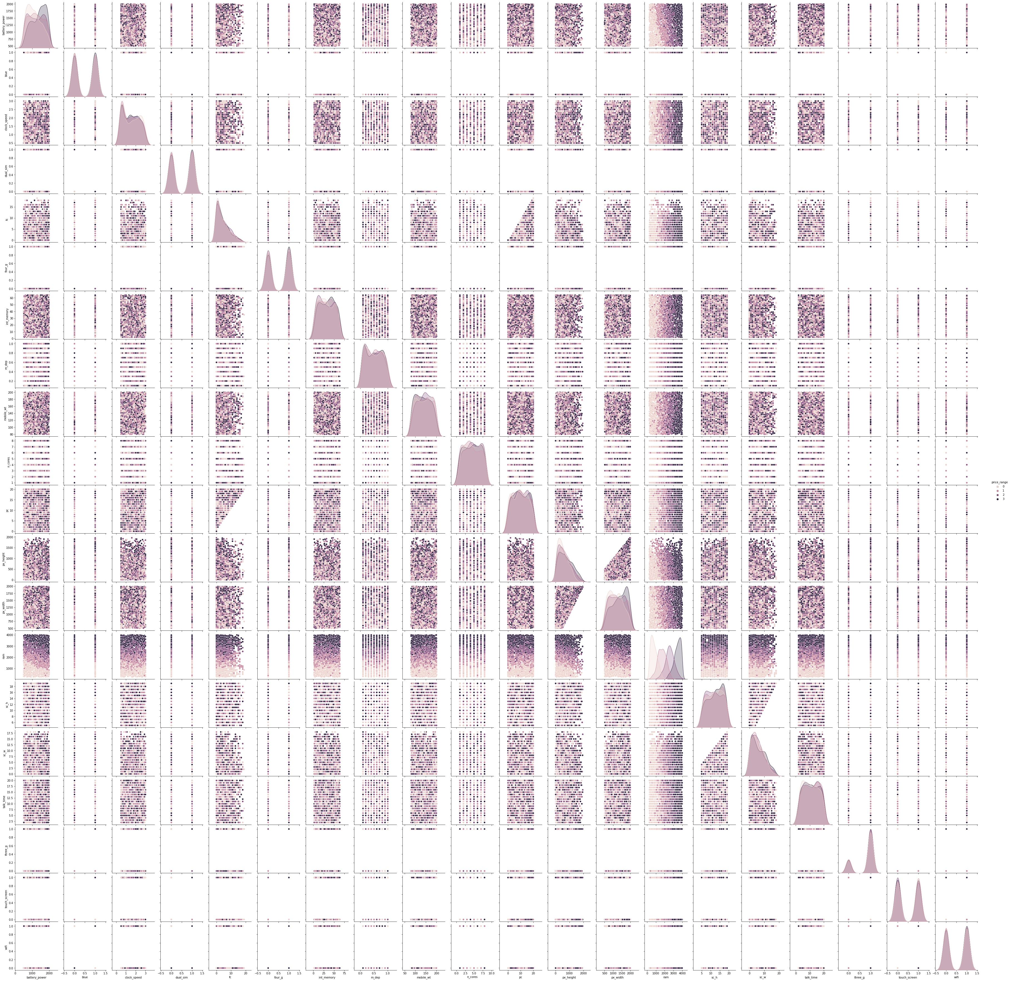*# Scatter plot for pc vs price_range* plt**.**figure(figsize**=**(8, 6)) sns**.**scatterplot(x**=**'pc', y**=**'price_range', data**=**df) plt**.**xlabel('Primary Camera (Mega Pixels)') plt**.**ylabel('Price Range') plt**.**title('Price Range vs Primary Camera') plt**.**show()

In [14]:

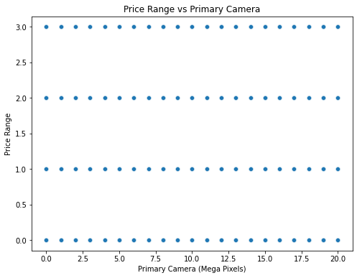*# Bar plot for pc vs price_range* plt**.**figure(figsize**=**(10, 6)) sns**.**barplot(x**=**'price_range', y**=**'pc', data**=**df) plt**.**xlabel('Price Range') plt**.**ylabel('Average Primary Camera (Mega Pixels)') plt**.**title('Average Primary Camera for Each Price Range') plt**.**show()

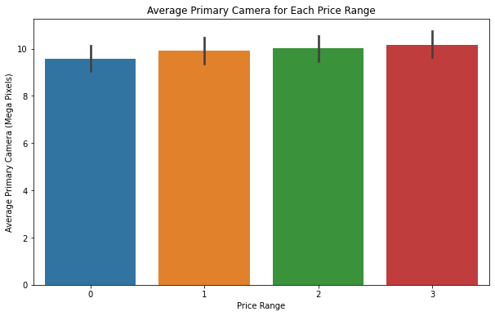

In [12]:

*# Scatter plot for fc vs price_range* plt**.**figure(figsize**=**(8, 6)) sns**.**scatterplot(x**=**'fc', y**=**'price_range', data**=**df) plt**.**xlabel('Front Camera (Mega Pixels)') plt**.**ylabel('Price Range') plt**.**title('Price Range vs Front Camera') plt**.**show()

In [15]:

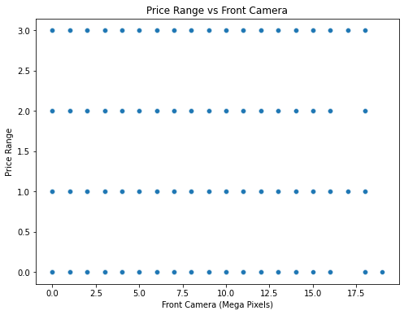*# Bar plot for fc vs price_range* plt**.**figure(figsize**=**(10, 6)) sns**.**barplot(x**=**'price_range', y**=**'fc', data**=**df) plt**.**xlabel('Price Range') plt**.**ylabel('Average Front Camera (Mega Pixels)') plt**.**title('Average Front Camera for Each Price Range') plt**.**show()

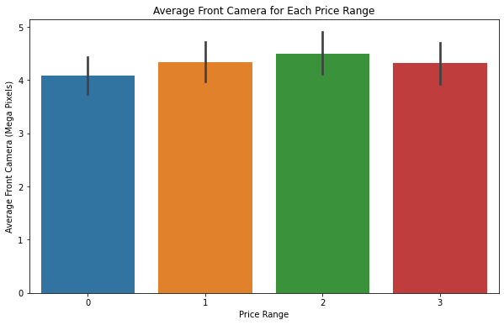

In [16]:

*# Calculate the average battery_power for each price_range category* average_battery_power **=** df**.**groupby('price_range')['battery_power']**.**mean()**.**reset_index()

*# Horizontal bar plot for battery_power vs price_range* plt**.**figure(figsize**=**(10, 6)) sns**.**barplot(x**=**'battery_power', y**=**'price_range', data**=**average_battery_power, orient**=**'h') plt**.**xlabel('Average Battery Power (mAh)') plt**.**ylabel('Price Range') plt**.**title('Average Battery Power for Each Price Range') plt**.**show()

In [17]:

*# Calculate the average n_cores for each price_range category* average_n_cores **=** df**.**groupby('price_range')['n_cores']**.**mean()**.**reset_index()

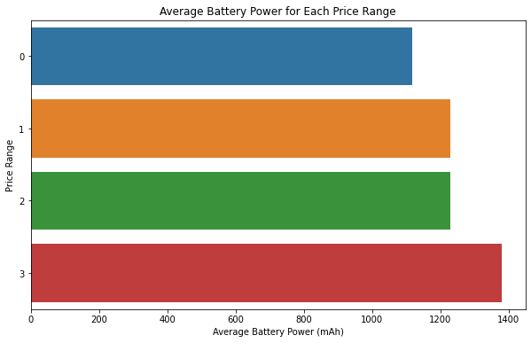*# Horizontal bar plot for n_cores vs price_range* plt**.**figure(figsize**=**(10, 6)) sns**.**barplot(x**=**'n_cores', y**=**'price_range', data**=**average_n_cores, orient**=**'h') plt**.**xlabel('Average Number of Cores') plt**.**ylabel('Price Range') plt**.**title('Average Number of Cores for Each Price Range') plt**.**show()

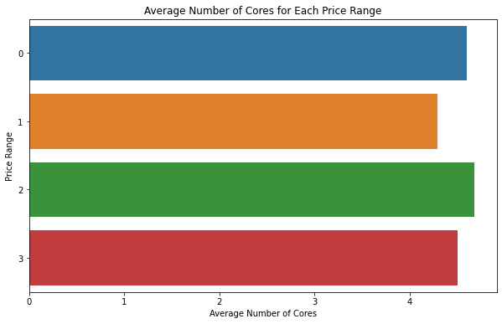

In [34]:

*# Extracting the data for the plot* px_width **=** df['px_width'] px_height **=** df['px_height'] price_range **=** df['price_range']

*# Create a scatter plot* plt**.**figure(figsize**=**(10, 8)) plt**.**scatter(px_width, px_height, c**=**price_range, cmap**=**'viridis', marker**=**'o', alpha**=**0.7)

*# Set labels for axes* plt**.**xlabel('Pixel Resolution Width') plt**.**ylabel('Pixel Resolution Height') plt**.**title('Relationship between Pixel Resolution and Price Range')

*# Adding a colorbar legend* cbar **=** plt**.**colorbar() cbar**.**set_label('Price Range', rotation**=**270, labelpad**=**15)

plt**.**show()

In [35]:

*# Group data by price_range and calculate the mean pixel resolution width and height for each category* grouped_df **=** df**.**groupby('price_range')[['px_width', 'px_height']]**.**mean()**.**reset_index()

*# Set up the bar plot* plt**.**figure(figsize**=**(10, 6)) bar_width **=** 0.35

*# Create bars for px_width and px_height* plt**.**bar(grouped_df['price_range'] **-** bar_width**/**2, grouped_df['px_width'], bar_width, label**=**'Pixel Width') plt**.**bar(grouped_df['price_range'] **+** bar_width**/**2, grouped_df['px_height'], bar_width, label**=**'Pixel Height')

*# Set labels for axes and title* plt**.**xlabel('Price Range') plt**.**ylabel('Average Pixel Resolution') plt**.**title('Average Pixel Resolution for Each Price Range Category') plt**.**xticks(grouped_df['price_range']) plt**.**legend()

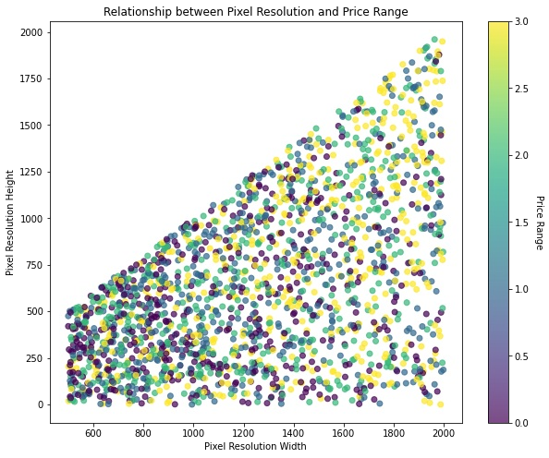plt**.**show()

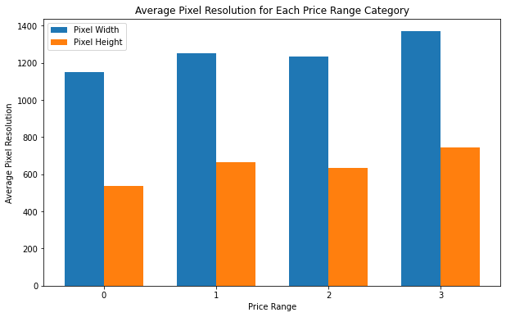

In [37]:

*# Calculate the average RAM for each price_range category* average_ram_by_price_range **=** df**.**groupby('price_range')['ram']**.**mean()**.**reset_index()

*# Create a bar plot to visualize the relationship between ram and price_range* plt**.**figure(figsize**=**(8, 6)) sns**.**barplot(x**=**'price_range', y**=**'ram', data**=**average_ram_by_price_range) plt**.**xlabel('Price Range') plt**.**ylabel('Average RAM (Random Access Memory in MB)') plt**.**title('Relationship between RAM and Price Range') plt**.**show()

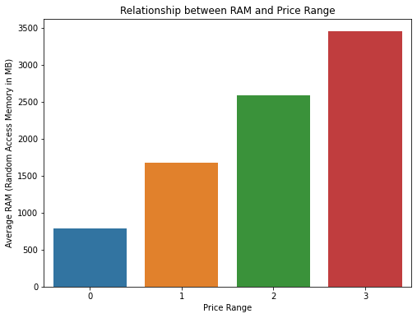

In [39]:

*# Create a count plot to visualize the relationship between three_g and price_range* plt**.**figure(figsize**=**(8, 6)) sns**.**countplot(x**=**'three_g', hue**=**'price_range', data**=**df, palette**=**'viridis') plt**.**xlabel('3G Connectivity') plt**.**ylabel('Count') plt**.**title('Relationship between 3G Connectivity and Price Range') plt**.**legend(title**=**'Price Range', labels**=**['Low Cost', 'Medium Cost', 'High Cost', 'Very High Cost']) plt**.**show()

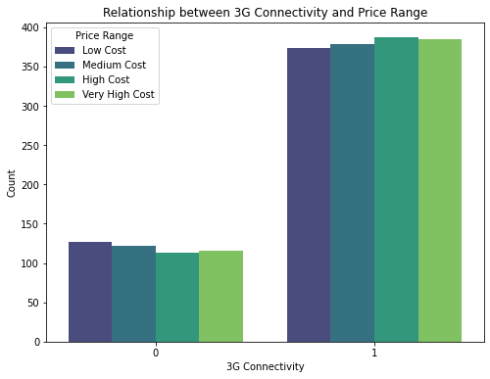

In [40]:

*# Create a count plot to visualize the relationship between four_g and price_range* plt**.**figure(figsize**=**(8, 6)) sns**.**countplot(x**=**'four_g', hue**=**'price_range', data**=**df, palette**=**'viridis') plt**.**xlabel('4G Connectivity') plt**.**ylabel('Count') plt**.**title('Relationship between 4G Connectivity and Price Range') plt**.**legend(title**=**'Price Range', labels**=**['Low Cost', 'Medium Cost', 'High Cost', 'Very High Cost']) plt**.**show()

In [53]:

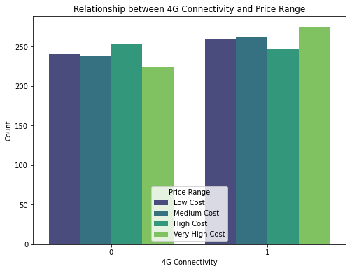*# Visualize the relationship between 'sc_h' and 'price_range' using a bar plot* plt**.**figure(figsize**=**(10, 6)) sns**.**barplot(x**=**'price_range', y**=**'sc_h', data**=**df) plt**.**xlabel('Price Range') plt**.**ylabel('Screen Height (cm)') plt**.**title('Relationship between Screen Height and Price Range') plt**.**show()

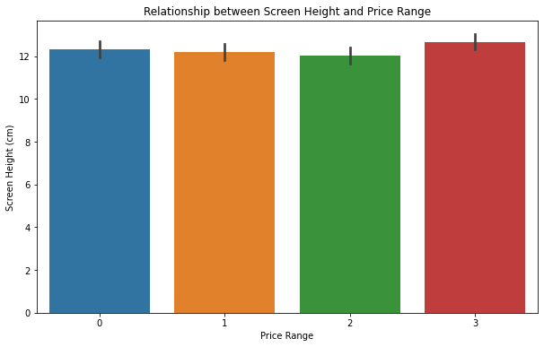

In [54]:

*# Visualize the relationship between 'sc_w' and 'price_range' using a bar plot* plt**.**figure(figsize**=**(10, 6)) sns**.**barplot(x**=**'price_range', y**=**'sc_w', data**=**df) plt**.**xlabel('Price Range') plt**.**ylabel('Screen Width (cm)') plt**.**title('Relationship between Screen Width and Price Range') plt**.**show()

In [55]:

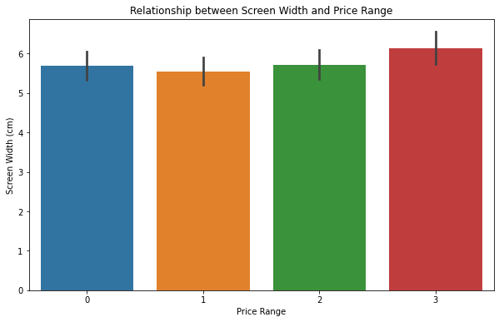*# Visualize the relationship between 'touch_screen' and 'price_range' using a bar plot* plt**.**figure(figsize**=**(8, 6)) sns**.**barplot(x**=**'touch_screen', y**=**'price_range', data**=**df) plt**.**xlabel('Touch Screen') plt**.**ylabel('Price Range') plt**.**title('Relationship between Touch Screen and Price Range') plt**.**show()

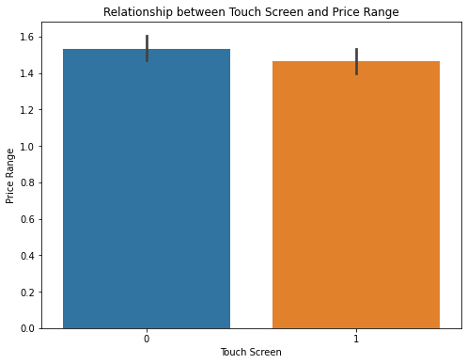

In [19]:

*# Calculate the correlation matrix* correlation_matrix **=** df**.**corr()

*# Create a heatmap for the correlation matrix* plt**.**figure(figsize**=**(18, 10)) sns**.**heatmap(correlation_matrix, annot**=True**, cmap**=**'coolwarm', fmt**=**'.2f') plt**.**title('Correlation Heatmap') plt**.**show()

In [29]:

**from** sklearn.model_selection **import** train_test_split **from** sklearn.ensemble **import** RandomForestClassifier

In [52]:

*# Features and target variable*

X_1 **=** df[['battery_power', 'blue', 'clock_speed', 'dual_sim', 'fc', 'four_g', 'int_memory', 'm_dep', 'mobile_wt', 'n_cores', 'pc', 'px_height', 'px_width', 'ram', 'sc_h', y_1 **=** df['price_range']

*# Split the data into training and testing sets*

X_1_train, X_1_test, y_1_train, y_1_test **=** train_test_split(X_1, y_1, test_size**=**0.2, random_state**=**42)

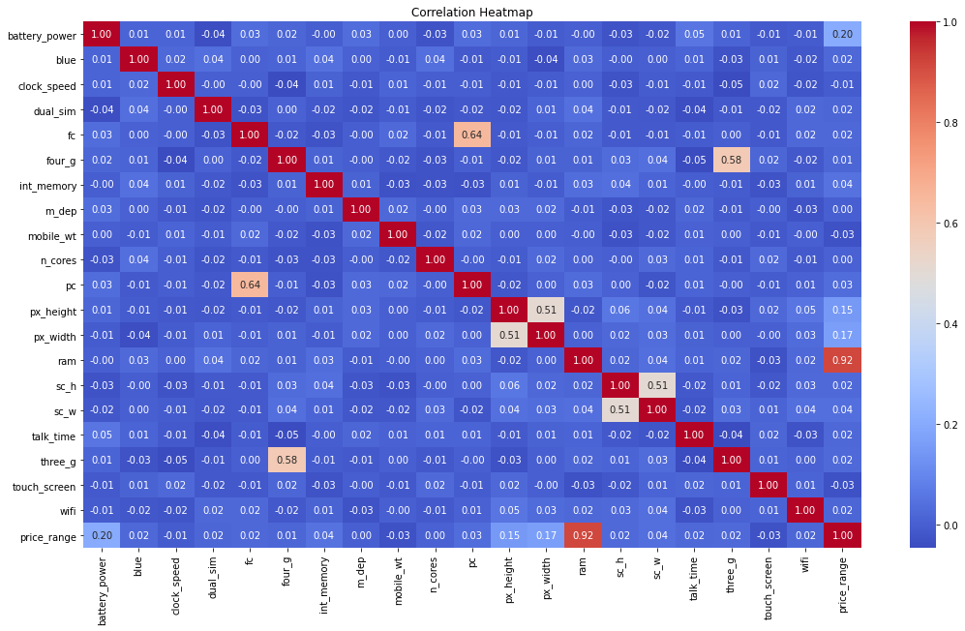*# Random Forest Classifier* random_forest_model **=** RandomForestClassifier(n_estimators**=**100, random_state**=**42) random_forest_model**.**fit(X_1_train, y_1_train)

*# Get feature importances and sort them in descending order* feature_importances **=** random_forest_model**.**feature_importances_ sorted_indices **=** feature_importances**.**argsort()[::**-**1] sorted_features **=** X_1**.**columns[sorted_indices] sorted_importances **=** feature_importances[sorted_indices]

*# Visualize feature importances* plt**.**figure(figsize**=**(12, 8)) sns**.**barplot(x**=**sorted_importances, y**=**sorted_features) plt**.**xlabel('Feature Importance') plt**.**ylabel('Feature') plt**.**title('Feature Importance in Predicting Price Range') plt**.**show()

**Model Building**

In [42]:

**from** sklearn.svm **import** SVC **from** sklearn.metrics **import** accuracy_score, classification_report

In [43]:

*# Separate features (X) and target variable (y)* X **=** df**.**drop('price_range', axis**=**1) y **=** df['price_range']

In [44]:

*# Split the data into training and testing sets (80% training, 20% testing)*

X_train, X_test, y_train, y_test **=** train_test_split(X, y, test_size**=**0.2, random_state**=**42)

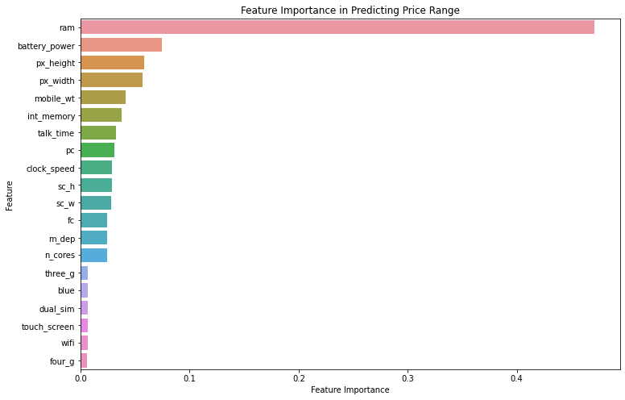In [45]:

*# Create and train the SVM model* svm_model **=** SVC(kernel**=**'linear', C**=**1.0, random_state**=**42) svm_model**.**fit(X_train, y_train)

Out[45]:

SVC(kernel='linear', random_state=42)

In [46]:

*# Predict on the test data* y_pred **=** svm_model**.**predict(X_test)

In [47]:

*# Evaluate the model* accuracy **=** accuracy_score(y_test, y_pred) classification_report_str **=** classification_report(y_test, y_pred)

In [49]:

print(X_test)

battery_power blue clock_speed dual_sim fc four_g int_memory \

1860 1646 0 2.5 0 3 1 25

353 1182 0 0.5 0 7 1 8

1333 1972 0 2.9 0 9 0 14

905 989 1 2.0 0 4 0 17 1289 615 1 0.5 1 7 0 58 ... ... ... ... ... .. ... ...

965 1379 0 0.5 1 1 0 19

1284 991 0 2.0 0 2 1 12

1739 1044 0 1.8 0 4 1 12

261 728 0 2.7 1 0 0 25 535 1185 0 1.9 0 0 0 31

m_dep mobile_wt n_cores pc px_height px_width ram sc_h sc_w \

1860 0.6 200 2 5 211 1608 686 8 6

353 0.5 138 8 16 275 986 2563 19 17

1333 0.4 196 7 18 293 952 1316 8 1

905 0.2 166 3 19 256 1394 3892 18 7 1289 0.5 130 5 8 1021 1958 1906 14 5

... ... ... ... .. ... ... ... ... ...

965 0.3 134 8 17 387 671 3912 11 2

1284 0.3 158 5 6 1209 1678 2014 11 9

1739 0.7 104 6 5 1230 1263 1794 18 7

261 0.2 88 4 1 526 1529 2039 5 1 535 0.4 152 8 7 837 1642 2447 16 2

talk_time three_g touch_screen wifi

1860 11 1 1 0

353 19 1 0 0

1333 8 1 1 0

905 19 1 1 0

1289 5 1 0 0 ... ... ... ... ...

965 19 0 1 1

1284 10 1 0 0

1739 19 1 1 1

261 12 1 1 1

535 3 1 1 1

[400 rows x 20 columns]

In [50]:

print(y_pred)

[0 2 1 3 1 1 2 0 3 1 0 1 2 3 3 2 3 3 1 0 0 2 1 2 0 1 3 2 2 0 0 0 3 0 1 1 2

0 3 0 2 3 2 0 2 3 2 1 3 1 3 1 0 0 1 1 1 3 0 0 1 3 3 1 0 0 3 3 1 2 2 2 0 1

2 0 1 3 2 2 3 2 1 0 1 3 1 3 3 0 3 3 2 1 3 2 2 3 1 1 0 0 1 0 1 3 2 0 1 1 0

1. 3 1 3 2 3 2 0 2 1 3 2 1 3 3 0 2 0 2 3 0 2 2 0 3 1 0 0 2 2 1 2 2 0 0 0 1
2. 2 3 1 1 0 2 2 0 1 0 2 2 3 3 3 1 0 1 2 2 3 3 0 1 0 3 1 1 2 1 0 0 0 0 0 3
3. 0 3 0 0 0 0 1 3 3 1 0 1 1 1 1 2 2 3 3 3 1 2 0 0 0 2 1 1 3 1 1 2 1 1 3 2
4. 0 0 2 1 3 0 1 2 0 2 3 2 0 1 3 3 0 1 3 3 3 0 3 1 2 3 3 2 1 1 3 3 1 3 3 3

3 3 0 1 2 2 1 3 0 2 3 2 2 2 1 0 1 0 3 3 1 3 1 1 3 1 2 0 0 3 0 1 2 3 3 3 1

1 0 1 3 3 0 1 2 2 0 3 3 2 3 2 3 2 0 2 1 1 1 0 0 0 3 3 3 1 0 1 0 1 2 3 0 3 3 2 1 3 0 0 2 1 3 2 0 1 1 1 1 1 3 2 0 0 3 3 0 3 0 0 2 0 1 2 2 2 3 0 3 2 3

3 3 3 2 1 1 0 3 1 3 3 0 2 3 2 3 3 3 0 0 2 3 0 0 2 3 2 1 1 2]

In [48]:

print(f"Accuracy: {accuracy:.2f}") print("Classification Report:") print(classification_report_str)

Accuracy: 0.97

Classification Report:

precision recall f1-score support

1. 1.00 0.94 0.97 105
2. 0.91 1.00 0.95 91
3. 0.99 0.95 0.97 92 3 0.98 0.99 0.99 112

accuracy 0.97 400 macro avg 0.97 0.97 0.97 400 weighted avg 0.97 0.97 0.97 400

**After applying StandardScaler**

In [56]:

**from** sklearn.preprocessing **import** StandardScaler

scaler **=** StandardScaler()

In [57]:

X_train_scaled **=** scaler**.**fit_transform(X_train)

X_test_scaled **=** scaler**.**transform(X_test)

In [58]:

svm_model_scaled **=** SVC(kernel**=**'linear', C**=**1.0, random_state**=**42) svm_model_scaled**.**fit(X_train_scaled, y_train)

Out[58]:

SVC(kernel='linear', random_state=42)

In [64]:

*# Predict on the test data* y_pred_scaled **=** svm_model**.**predict(X_test_scaled)

In [65]:

*# Evaluate the model* accuracy_scaled **=** accuracy_score(y_test, y_pred_scaled) classification_report_str_scaled **=** classification_report(y_test, y_pred_scaled)

In [66]:

print("Using StandardScaler:") print(f"Accuracy: {accuracy_scaled:.2f}") print("Classification Report:") print(classification_report_str_scaled)

Using StandardScaler:

Accuracy: 0.26

Classification Report:

precision recall f1-score support

1. 0.26 1.00 0.42 105
2. 0.00 0.00 0.00 91
3. 0.00 0.00 0.00 92 3 0.00 0.00 0.00 112

accuracy 0.26 400 macro avg 0.07 0.25 0.10 400 weighted avg 0.07 0.26 0.11 400

**After applying MinMaxScaler**

In [67]:

**from** sklearn.preprocessing **import** MinMaxScaler

mms **=** MinMaxScaler()

X_train_mms_scaled **=** mms**.**fit_transform(X_train) X_test_mms_scaled **=** mms**.**transform(X_test) svm_model_mms **=** SVC(kernel**=**'linear', C**=**1.0, random_state**=**42) svm_model_mms**.**fit(X_train_mms_scaled, y_train)

y_pred_mms **=** svm_model_mms**.**predict(X_test_mms_scaled) accuracy_mms **=** accuracy_score(y_test, y_pred_mms) classification_report_str_mms **=** classification_report(y_test, y_pred_mms)

print("Using MinMaxScaler:") print(f"Accuracy: {accuracy_mms:.2f}") print("Classification Report:") print(classification_report_str_mms) Using MinMaxScaler:

Accuracy: 0.96

Classification Report:

precision recall f1-score support

1. 1.00 0.97 0.99 105
2. 0.92 1.00 0.96 91
3. 0.95 0.90 0.93 92 3 0.96 0.96 0.96 112

accuracy 0.96 400 macro avg 0.96 0.96 0.96 400 weighted avg 0.96 0.96 0.96 400

Conclusion

The high accuracy of 97% in the first case indicates that the model is able to predict the mobile phone price range with high accuracy when features are used without any scaling.

The low accuracy of 26% in the second case shows that the model's performance drastically drops when features are not scaled properly. This implies that scaling is essential for improving the model's performance.

The accuracy of 96% in the third case suggests that using MinMaxScaler helps in improving the model's performance compared to the second case but is slightly lower than the first case. MinMaxScaler scales the features to a specific range, which seems to help the model make better predictions.

Overall, scaling the features using appropriate scalers can have a significant impact on the model's performance, and it is essential to choose the right scaling method depending on the data and the machine learning algorithm being used.

In [ ]: